ALTERNATING CODING AND EFFICIENT DECODERS DESIGNED ON THE BASIS OF IT FOR IMAGE CODING
Mid-Sweden University, Dept. of Information Technology and Media, Electronics Design Division
Shang Xue and Bengt Oelmann

Introduction
The image data such as the motion-vector and the transformed coefficients can usually be modelled by the Generalized Gaussian (GG) distribution and are then coded using Exp-Golomb (EG) coded or Golomb-Rice (GR) code. GR and EG codes are both nearly optimum for GG sources. For instance, Universal Variable Length Code (UVLC), which is used universally in the coding of all image data types in H.26L, is actually a reversible EG code. This work studies the coding characteristics of image data (GG sources). Based on this study, another nearly optimal code -- Hybrid Golomb code (HG), as well as an efficient coding method -- Alternating Coding (ALT) are proposed for GG shaped data sources. Efficient decoders are then designed on the basis of ALT coding. ALT coding is applied to the GR code and the EG code. Results show that ALT coded UVLC packet conceives same coding efficiency, whereas the error resiliency and robustness are improved. Moreover, UVLC and GR decoders designed on the basis of the ALT coding are greatly enhanced in terms of speed, area and power consumption.
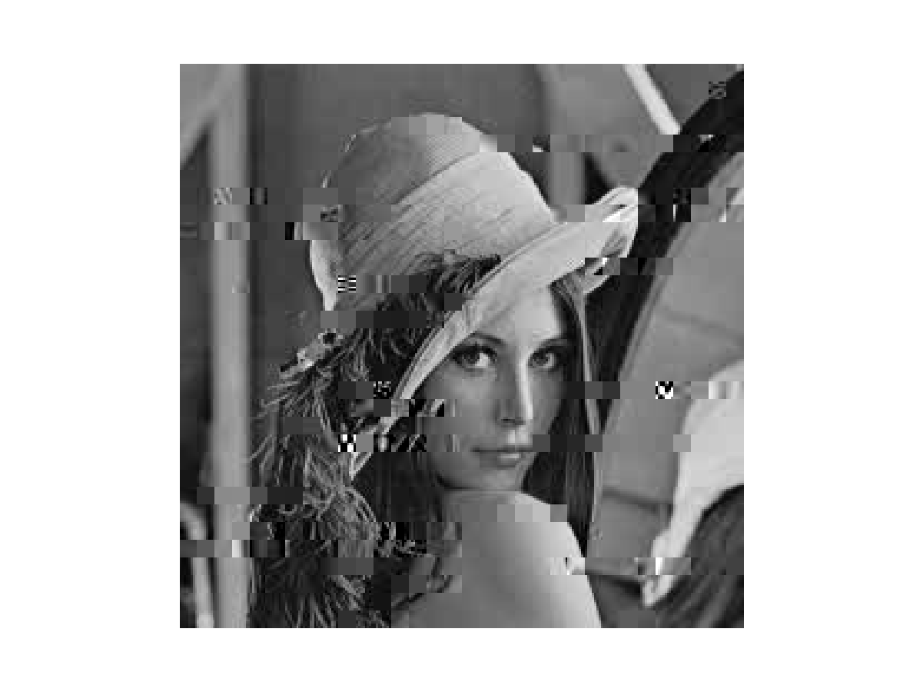
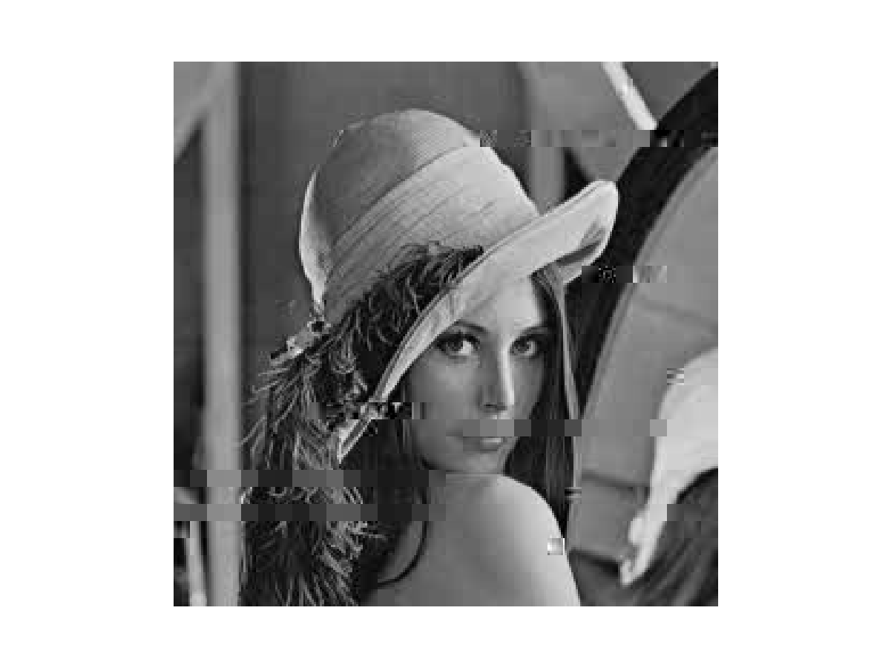
Alt coding and image decoders based on it
Normal UVLC
ALT coding
The basic idea of ALT coding is to separates the code into two parts, one part contains the code length information, while another can be determinded by the first part. The first part is then coded using two code tables alternatingly with the codeword boundaries obviously marked. The two parts of codes are then transimitted separately. Take UVLC as an example. Table 1 shows an example of UVLC.

Table 1. An example of UVLC
Class | UVLC | Length | Value to be expressed
1 | 1 | 1 | 1
2 | 0x₀0 | 3 | ’x₀’+ 2[2:3]
3 | 0x₁1x₀0 | 5 | ’x₁x₀’+ 4[4:7]
4 | 0x₂1x₁1x₀0 | 7 | ’x₂x₁x₀’+ 8[8:15]
… | … … | … | … …
Here, odd-indexed bits (OIB) of each UVLC can be represented in a unary way which contains code length information. The OIBs are then coded using either {1, 11, 111, 1111, …} or {0, 00, 000, 0000, …}, in an alternating way. Its even-indexed bits (EIB) is an arbitrary binary code whose length is determined by its corresponding OIB. The whole packet is then transmitted as Figure 1 illustrates.
The advantages of ALT:
… … …
… … …
Sync.
Marker
Sync.
Marker
OIB sequence
EIB sequence
Sync.
Marker
UVLC1
UVLC2
UVLC3
… …
UVLCn
Sync.
Marker
OIB1
OIB2
OIB3
OIBn
EIB1
EIB2
EIB3
EIBn
Figure 1. ALT coding for UVLC
- Immediate code boundary detection (hardware/software)
- Easy error detection and location (software)
The ALT decoders, obviously, should have two parts, one decoder decodes each code length (this can be done in parallel), and another decodes the rest of the code.
Results & Future work
Simulations were conducted to demonstrate the error resilience of ALT coding and the efficiency of the ALT decoders.
- Error resiliency demonstrated by Correct Ratio (CR)

Visual quality of ALT coded images

Table 2. Comparison of PSNR of the UVLC decoders
Image | PSNR of UVLC (dB) | PSNR of ALT (dB)
Lena | 21.92 | 27.50
Cameraman | 24.23 | 3146
Monkey | 17.81 | 22.38
House | 27.67 | 30.07

VLSI Implementation of ALT decoders

Table 3. Comparison of performance of the UVLC decoders
 | ALT | PLS | Ratio (ALT/PLS)
Delay (ns) | 8.96 | 12.0 | 75%
Area (gates) | 1855 | 3146 | 59%
Power (mW) | 6.74 | 15.0 | 45%

Table 4. Comparison of performance of the GR* decoders
 | ALT | PLS | Ratio (ALT/PLS)
Delay (ns) | 8.91 | 10.15 | 88%
Area (gates) | 736 | 1441 | 51%
Power (mW) | 3.9 | 13.8 | 28%
GR with one bit suffix
Future work will be focused on further exploring new codes for GG sources and applying ALT coding to them.

