Ultra-Low Power Electronics Using Floating-Gate Transistors
Mid-Sweden University, Dept. of Information Technology and Media, Electronics Design Division
Bengt Oelmann

Project Description
The goal of this project is to develop techniques and methods for floating-gate circuits that allow the same degree of design automation as digital standard-cell design does today but resulting in circuits with three to four orders of magnitude lower energy consumption.

Introduction
In recent years there has been a growing interest in research in digital design for ultra-low power consumption. Here the figure of merit is basically only the power consumption and the speed requirements are low or very low. Self-contained systems with own power supply where the energy resources must sustain for their entire lifetime need ultra-low power circuits. By using floating-gate transistors operating in sub-threshold mode, large reductions in energy consumption can be achieved.

UV-Programmable Floating-Gates
In this project we are working with floating-gate circuits manufactured in a standard CMOS technology. The voltages on the floating-gates are controlled by a post-fabrication process that is called “programming”.

The main motives for using floating-gates are:
- Enables compact implementations of logic gates using Linear-Threshold Elements
- Sub-threshold operation is facilitated by a post-fabrication step for cancellation of processes variations

The post-fabrication step:
- For programming, UV-light is used for activation of electrical paths to the floating-gates
- Programming enables post-fabrication tuning of threshold voltage of the floating-gate transistor

Linear Threshold Elements

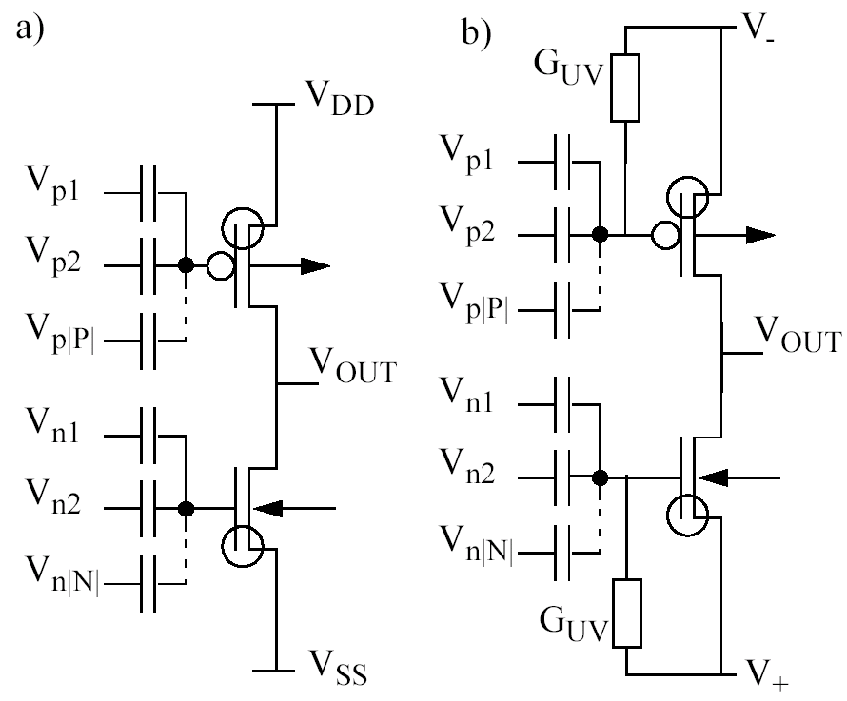

Programming and Characterization Site

